Image Compression

PRACTICAL NEEDS FOR IMAGE AND VIDEO COMPRESSION

Video as a sequence of video frames, however, involves a huge amount of data. Let us take a look at an illustrative example. Assume the present switch telephone network (PSTN) modem can operate at a maximum bit rate of 56,600 bits per second. Assume each video frame has a resolution of 288 by 352 (288 lines and 352 pixels per line), which is comparable with that of a normal TV picture and is referred to as common intermediate format (CIF). Each of the three primary colors RGB (red, green, blue) is represented for 1 pixel with 8 bits, as usual, and the frame rate in transmission is 30 frames per second to provide a continuous motion video. The required bit rate, then, is 288x352x8x3x30 = 72,990,720 bps. Therefore, the ratio between the required bit rate and the largest possible bit rate is about 1289. This implies that we have to compress the video data by at least 1289 times in order to accomplish the transmission described in this example. Note that an audio signal has not yet been accounted for yet in this illustration.
Compression can be categorized in two broad ways:
Lossless Compression: where data is compressed and can be reconstituted (uncompressed) without loss of detail or information. These are referred to as bit-preserving or reversible compression systems also.

Lossy Compression: where the aim is to obtain the best possible fidelity for a given bit-rate or minimizing the bit-rate to achieve a given fidelity measure. Video and audio compression techniques are most suited to this form of compression.
If an image is compressed it clearly needs to uncompressed (decoded) before it can viewed/listened to. Some processing of data may be possible in encoded form however.
Lossless compression frequently involves some form of entropy encoding and are based in information theoretic techniques.
Lossy compression use source encoding techniques that may involve transform encoding, differential encoding or vector quantization.
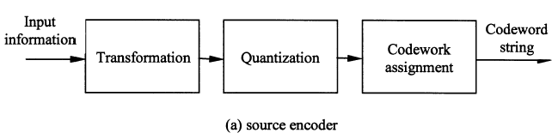

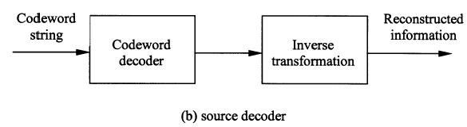
Block diagram of a source encoder and a source decoder.

TRANSFORMATION
The role of the transformation in data compression is to decorrelate and, more generally, to remove dependency between the data values, but without losing any information. For example, the transformation should be invertible. Common block transforms include the DFT and DCT.

For a data array of rectangular support [0, N1 - 11 x [0, N2 - I], the 2-D DCT is given as:
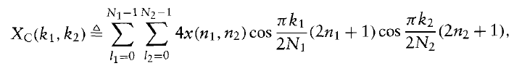
for (kl, k2) in [0, N1 – 1] x [0, N2 – 1]. Otherwise Xc(kl, kz) = 0.

The total number of blocks then becomes L1/N1 x L2/N2, where the last block in each line and column may be a partial block.
The DCT coefficients in a given block are approximately uncorrelated. We can expect the coefficients from different blocks to be approximately uncorrelated because of their distance from one another, if the blocksize is not too small.

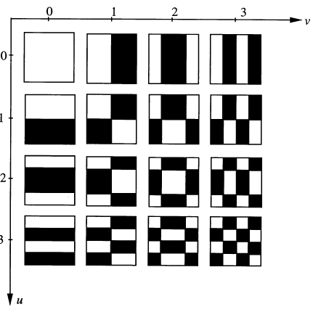
When N = 4: a set of the 16 basis images of the ordered DHT.

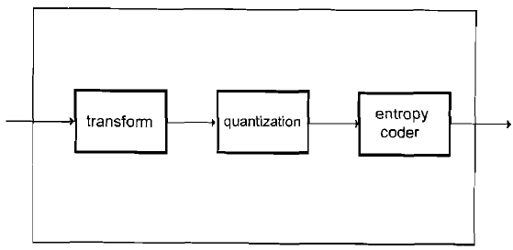

QUANTIZATION
- UNIFORM QUANTIZATION
- ADAPTIVE QUANTIZATION

a) UNIFORM QUANTIZATION
Uniform quantization is the simplest and most popular quantization technique. Conceptually, it is of great importance. Hence, we start our discussion on quantization with uniform quantization. Several fundamental concepts of quantization are introduced in this section.
Definitions
Take a look at the following figure. The horizontal axis denotes the input to a quantizer, while the vertical axis represents the output of the quantizer. The relationship between the input and the output best characterizes this quantizer; this type of configuration is referred to as the input-output characteristic of the quantizer. It can be seen that there are nine intervals along the x-axis. Whenever the input falls in one of the intervals, the output assumes a corresponding value. The input-output characteristic of the quantizer is staircase-like and, hence, clearly nonlinear.
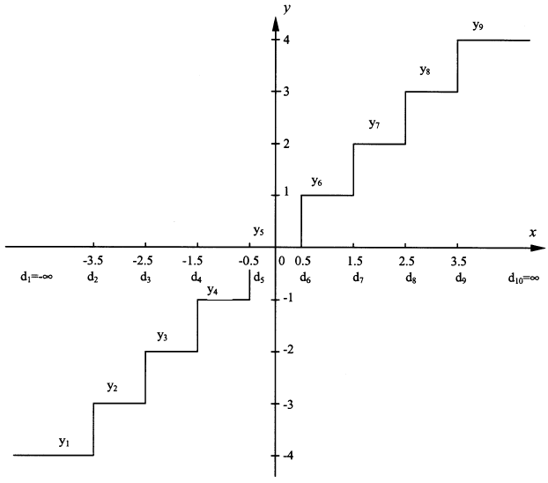
Input-output characteristic of a uniform midtread quantizer.

We can now mathematically define the function of the quantizer in the above Figure.

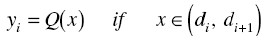
Where i= 1,2,… ,9 and Q(x) is the output of the quantizer with respect to the input x
.
The uniform quantizer is called midtread quantizer. Its counterpart is called a midrise quantizer, in which the reconstructed levels do not include the value of zero. Midtread quantizers are usually utilized for an odd number of reconstruction levels and midrise quantizers are used for an even number of reconstruction levels.
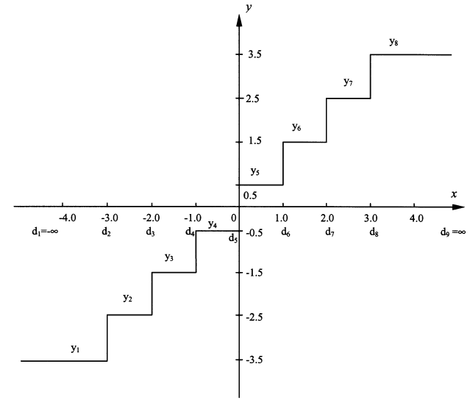
Input-output characteristic of a uniform midrise quantizer.

In dealing with quantization, we define quantization error, eq, as the difference between the input signal and the quantized output:
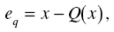
Where x and Q(x) are input and quantized output, respectively. Quantization error is often referred to as quantization noise.

b) ADAPTIVE QUANTIZATION
In the previous section, we studied nonuniform quantization, whose motivation is to minimize the mean square quantization error MSEq. We found that nonuniform quantization is necessary if the pdf of the input random variable x is not uniform.

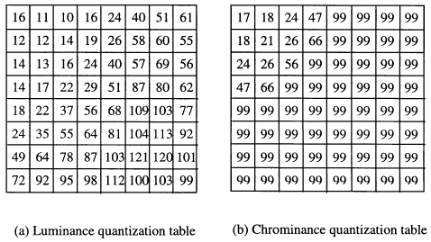

Coding Techniques

Entropy Coder
In general, we can use a fixed length or variable-length code for this purpose.

Simple Repetition Suppression
If in a sequence a series on n successive tokens appears we can replace these with a token and a count number of occurrences. We usually need to have a special flag to denote when the repeated token appears
For Example
89400000000000000000000000000000000
we can replace with
894f32
where f is the flag for zero.
Compression savings depend on the content of the data.
Applications of this simple compression technique include:
- Suppression of zero's in a file (Zero Length Supression)
  - Silence in audio data, Pauses in conversation etc.
  - Bitmaps
  - Blanks in text or program source files

Run-length Encoding
This encoding method is frequently applied to images (or pixels in a scan line). It is a small compression component used in JPEG compression.
In this instance, sequences of image elements X₁, X₂, …X_{n} are mapped to pairs (c₁,l₁), (c₂, l₂), …,(c_{n},l_{n}) where c_{i} represent image intensity or color and l_{i} the length of the ith run of pixels (Not dissimilar to zero length suppression above).
For example:
Original Sequence:
111122233333311112222
can be encoded as:
(1,4),(2,3),(3,6),(1,4),(2,4)
The savings are dependent on the data. In the worst case (Random Noise) encoding is more heavy than original file

Huffman coding
In the 1950s, David Huffman came up with an optimal variable-length encoding procedure, which came to be known as Huffman coding. It is a method for coding a finite number of messages into variable-length binary codewords in such a way that the average codeword length is minimized. Huffman coding creates a binary tree by first joining together the two messages with the lowest probabilities, thereby creating a reduced source with one fewer messages. It then proceeds recursively to join together the two messages with lowest probability for this reduced source, proceeding down to a root node whose probability is 1. When the branches of this tree are populated with 1s and Os, a variable-length code can be read off in the reverse order. This is perhaps best illustrated by example.

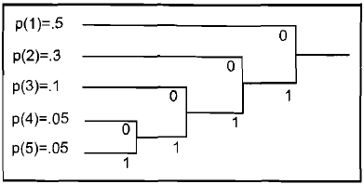

EXAMPLE (Huffman coding)
Let the source have M = 5 messages, with probabilities pl = 0.5, pz = 0.3, p3 = 0.1, p4 = 0.05, p5= 0.05. Then we can construct the Huffman code as shown in the above Figure. Here, starting from the left, messages 4 and 5 have the lowest probabilities, and so, are combined first. Their total probability is then 0.1. It happens that this node is also a smallest probability in the reduced source, and it is joined with message 3 with p(3) = 0.1 at the second level. We continue on to complete the tree. The variable-length codewords are now read from right to left and become, reading from message 1 to message 5: 0,10,110,1110, and 1111, with lengths 1, = 1,2: 3,4, and 5, respectively.
We note that this variable-length code is uniquely decodable, because no code word is the prefix of another codeword. It can be seen that the Huffman code tree guarantees that this will always be true. Computing the average codeword length, we get
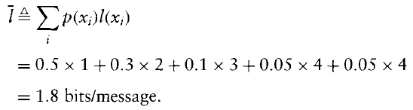
In this case the entropy is H = 1.786.

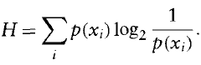
We note that the average codeword length for this example is quite close to the entropy of the source. This is not always the case, especially when the entropy per message is much less than one.
In passing, we note that the Huffman variable-length tree is complete, i.e., all branches terminate in valid messages. Hence the resulting variable-length code will be sensitive to channel errors.

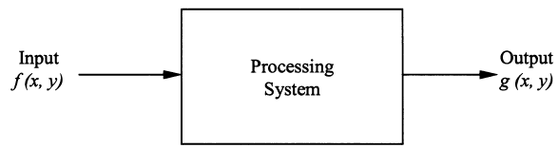

An image processing system.

Signal-to-Noise Ratio
Consider the above figure, where ƒ(x,y) is the input image to a processing system. The system can be a low-pass filter, a subsampling system, or a compression system. It can even represent a process in which additive white Gaussian noise corrupts the input image. The g(x,y) is the output of the system. In evaluating the quality of g(x, y), we define an error function e(x, y) as the difference between the input and the output. That is,
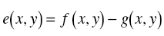
The mean square error is defined as Erm:
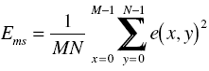
where M and N are the dimensions of the image in the horizontal and vertical directions. Note that it is sometimes denoted by MSE. The root mean square error is defined as Erms:

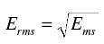
It is sometimes denoted by RMSE.
As noted earlier, SNR is widely used in objective quality measurement. Depending whether mean square error or root mean square error is used, the SNR may be called the mean square signal-to-noise ratio, SNRms, or the root mean square signal-to-noise ratio, SNRrms. We have

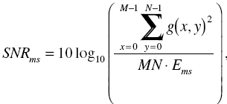
and

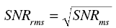
In image and video data compression, another closely related term, PSNR (peak signal-to-noise ratio), which is essentially a modified version of SNRms, is widely used. It is defined as follows.
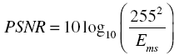
The interpretation of the SNRs is that the larger the SNR (SNRms, SNRrms, or PSNR) the better the quality of the processed image, g(x, y); that is, the closer the processed image g(x,y) is to the original image f (x, y). This seems to be correct.

Differential Coding
Instead of encoding a signal directly, the differential coding technique codes the difference between the signal itself and its prediction. Therefore it is also known as predictive coding. By utilizing spatial and/or temporal interpixel correlation, differential coding is an efficient and yet computationally simple coding technique.

When the difference signal (also known as prediction error) is quantized, the differential coding is called differential pulse code modulation (DPCM).

1-D, 2-D, AND 3-D DPCM
In general, 1-D DPCM may use the reconstructed gray level values of more than one of the preceding pixels within the same scan line to predict that of a pixel being coded. By far, however, the immediately preceding pixel in the same scan line is most frequently used in 1-D DPCM. That is, pixel A, in the following Figure, is often used as a prediction of pixel Z, which is being DPCM coded.

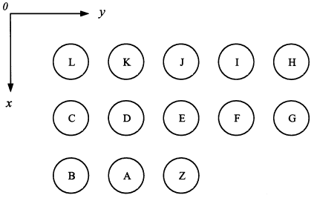

Pixel arrangement in 1-D and 2-D prediction.

Sometimes in DPCM image coding, both the decoded intensity values of adjacent pixels within the same scan line and the decoded intensity values of neighboring pixels in different scan lines are involved in the prediction. This is called 2-D DPCM. Note that the pixels involved in the prediction are restricted to be either in the lines above the line where the pixel being coded, Z, is located or on the lefthand side of pixel Z if they are in the same line. Traditionally, a TV frame is scanned from top to bottom and from left to right. Hence, the above restriction indicates that only those pixels, which have been coded and available in both the transmitter and the receiver, are used in the prediction. An often used 2-D prediction involves pixels A, D, and E.

Still Image Coding Standard: JPEG
This standard allows for lossy and lossless encoding of still images and four distinct modes of operation are supported: (1) sequential DCT-based mode, (2) progressive DCT-based mode, (3) lossless mode and (4) hierarchical mode. JPEG2000 is using the wavelet.

1) In the sequential DCT-based mode, an image is first partitioned into blocks of 8x8 pixels. The blocks are processed from left to right and top to bottom. The 8x8 two-dimensional Forward DCT is applied to each block and the 8x8 DCT coefficients are quantized. Finally, the quantized DCT coefficients are entropy encoded and output as part of the compressed image data.

2) In the progressive DCT-based mode, the process of block partitioning and Forward DCT transform is the same as in the sequential DCT-based mode. However, in the progressive mode, the quantized DCT coefficients are first stored in a buffer before the encoding is performed. The DCT coefficients in the buffer are then encoded by a multiple scanning process. In each scan, the quantized DCT coefficients are partially encoded by either spectral selection or successive approximation. In the method of spectral selection, the quantized DCT coefficients are divided into multiple spectral bands according to a zigzag order. In each scan, a specified band is encoded. In the method of successive approximation, a specified number of most significant bits of the quantized coefficients are first encoded and the least significant bits are then encoded in subsequent scans.

The difference between sequential coding and progressive coding is shown in the following Figures. In the sequential coding an image is encoded part by part according to the scanning order, while in the progressive coding the image is encoded by a multiscanning process and in each scan the full image is encoded to a certain quality level.

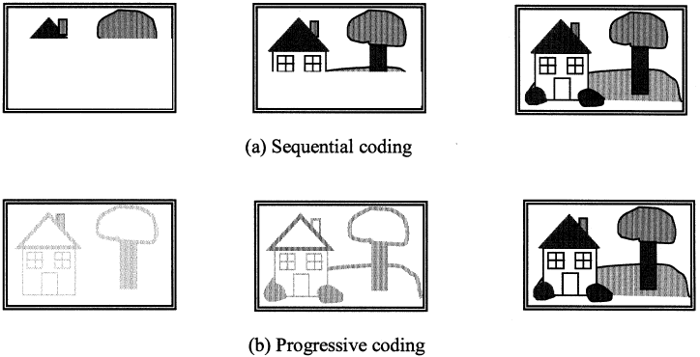

3) As mentioned earlier, lossless coding is achieved by a predictive coding scheme. In this scheme, three neighboring pixels are used to predict the current pixel to be coded. The prediction difference is entropy coded using either Huffman or arithmetic coding. Since the prediction is not quantized, the coding is lossless.

4) Finally, in the hierarchical mode, an image is first spatially down-sampled to a multilayered pyramid, resulting in a sequence of frames. This sequence of frames is encoded by a predictive coding scheme. Except for the first frame, the predictive coding process is applied to the differential frames, i.e., the differences between the frame to be coded and the predictive reference frame. It is important to note that the reference frame is equivalent to the previous frame that would be reconstructed in the decoder. The coding method for the difference frame may use the DCT-based coding method, the lossless coding method, or the DCT-based processes with a final lossless process. Down-sampling and up-sampling filters are used in the hierarchical mode. The hierarchical coding mode provides a progressive presentation similar to the progressive DCT-based mode, but is also useful in the applications that have multiresolution requirements. The hierarchical coding mode also provides the capability of progressive coding to a final lossless stage.

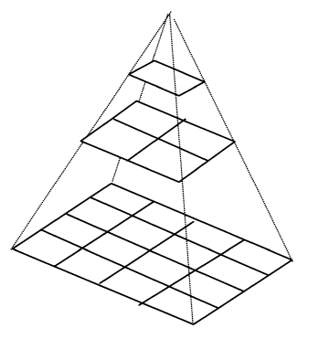
Hierarchical multiresolution encoding.

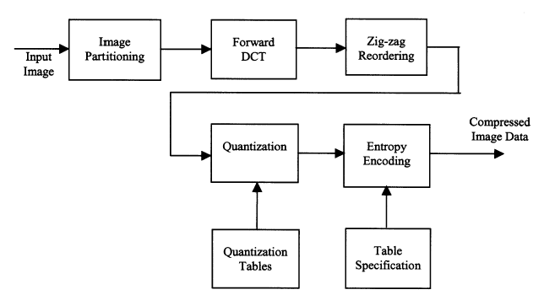

Block diagram of a sequential DCT-based encoding process.

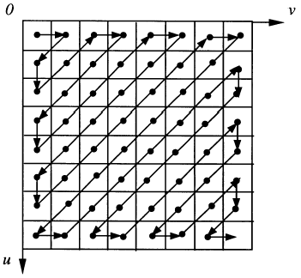
Zigzag scan of DCT coefficients within an 8 x  8 block.

Pulse code modulation (PCM)
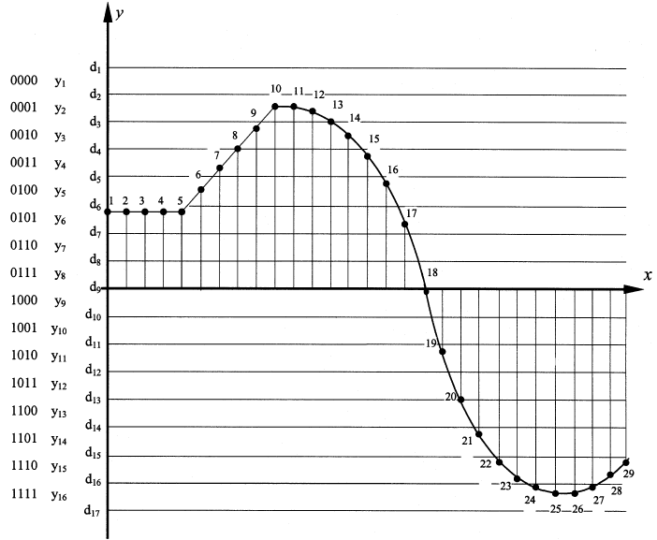
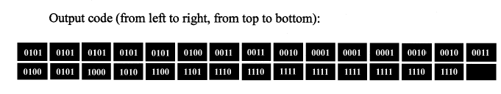
Pulse code modulation (PCM).

Nowadays, pulse code modulation is the most frequently used form of pulse modulation due to its robustness against noise. PCM consists of three stages: sampling, quantization, and encoding.
Analog signals are first sampled with a proper sampling frequency. The sampled data are then quantized using a uniform quantizer. Finally, the quantized values are encoded with natural binary code. It is the best established and most applied coding system. Despite its bit-consuming feature, it is utilized in almost all coding systems.

